Getting My COVID-19 Vaccine!

The COVID-19 Virus, or Coronavirus, has been something that was really unexpected. A virus is a type of germ that if it gets inside your body can make you sick.
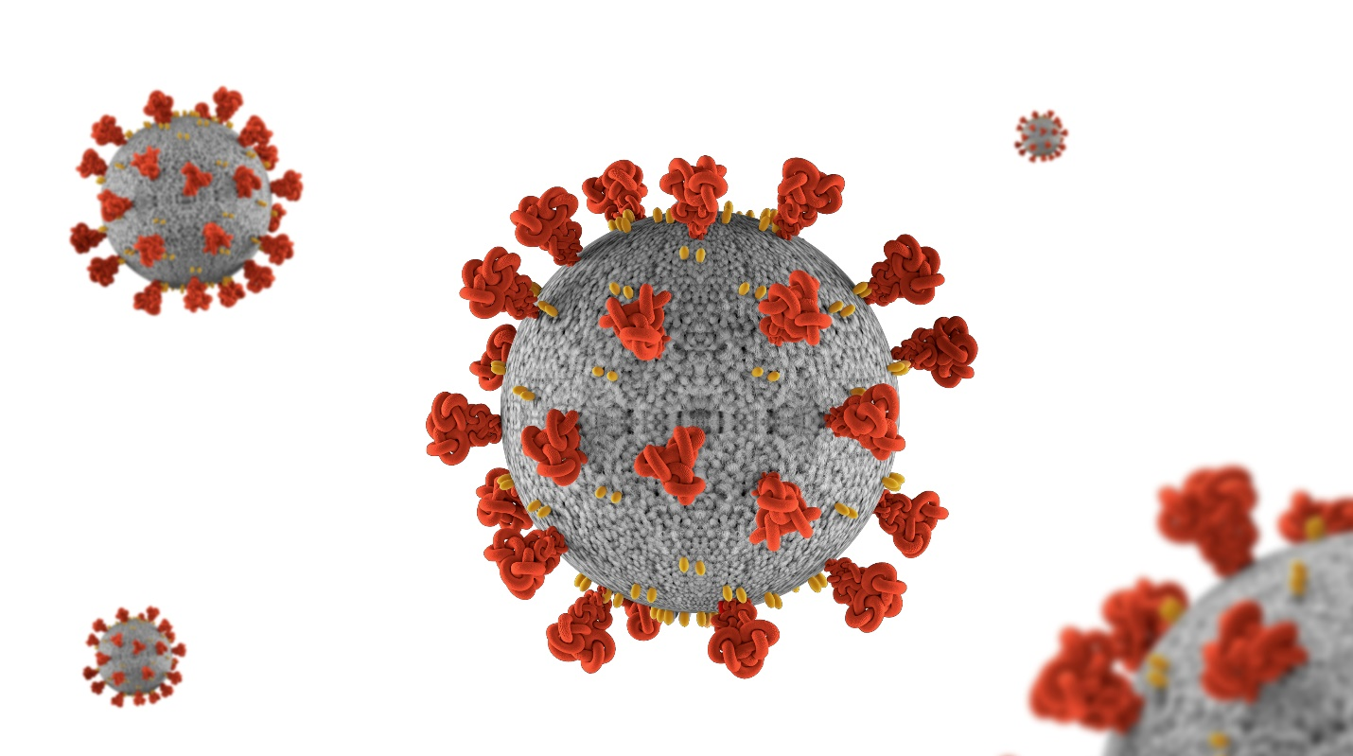

The last two years, the grownups have been working to figure out how to keep everyone safe from the COVID-19 virus. Sometimes this has meant that we all stayed home more often, wore masks, or found new ways to celebrate holidays. Most kids even did school on the computer for a while!
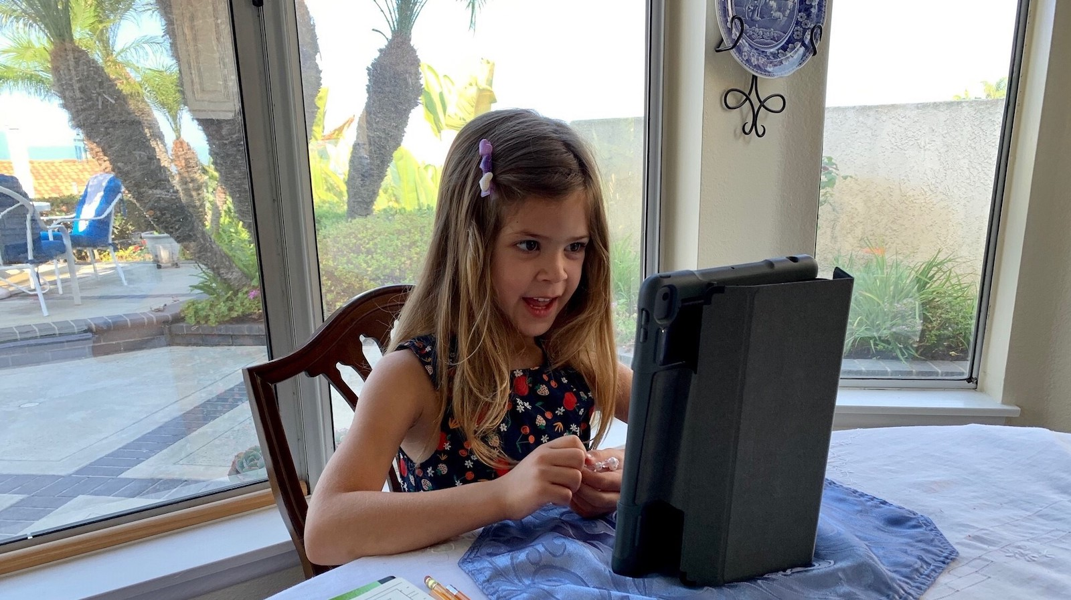

But, the best way to stay safe from a virus is to have something called a vaccine. A vaccine is medicine that is usually in a shot. The shot gives you a type of superpower because the vaccine teaches your body how to fight off the virus.

At first, we didn’t have a vaccine for the COVID-19 virus because it was a new germ. But the scientists got right to work. They have worked together to have a vaccine.

The COVID-19 vaccine is very exciting because it means that we can all do more fun things while staying healthy!

Places like pharmacies, grocery stores, and doctor’s offices got special equipment and training so they can give people the COVID-19 vaccine. Your grown up will take you to the place in your city that is the best place for you to get your shot.

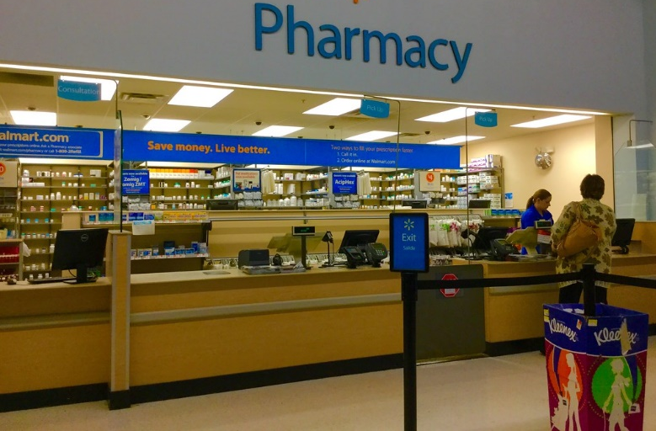

When you get there, your grown up will need to check you in and probably sign some papers.
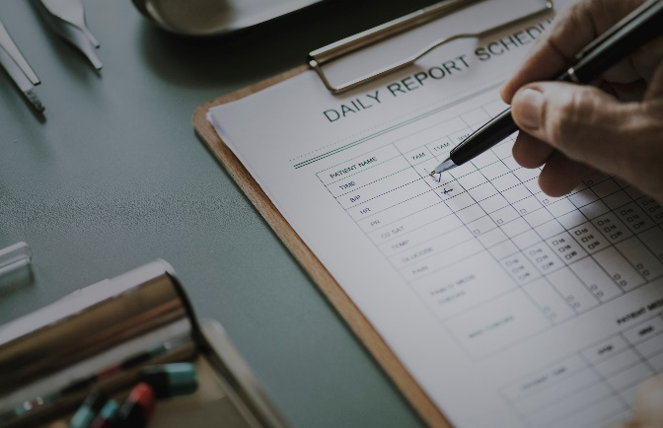

When it is your turn, the nurse or doctor will show you where to sit. They will get their supplies ready. This is a good time to look at a book, toy, or even see if you can watch a video on your grownup’s phone!

You will feel a cold wipe on your arm. This is a little pad that cleans your skin. The wipe does not hurt. Then, the nurse or doctor will give you your shot. It may feel like a pinch. It does not last long, it will probably be done before you can count to 10!
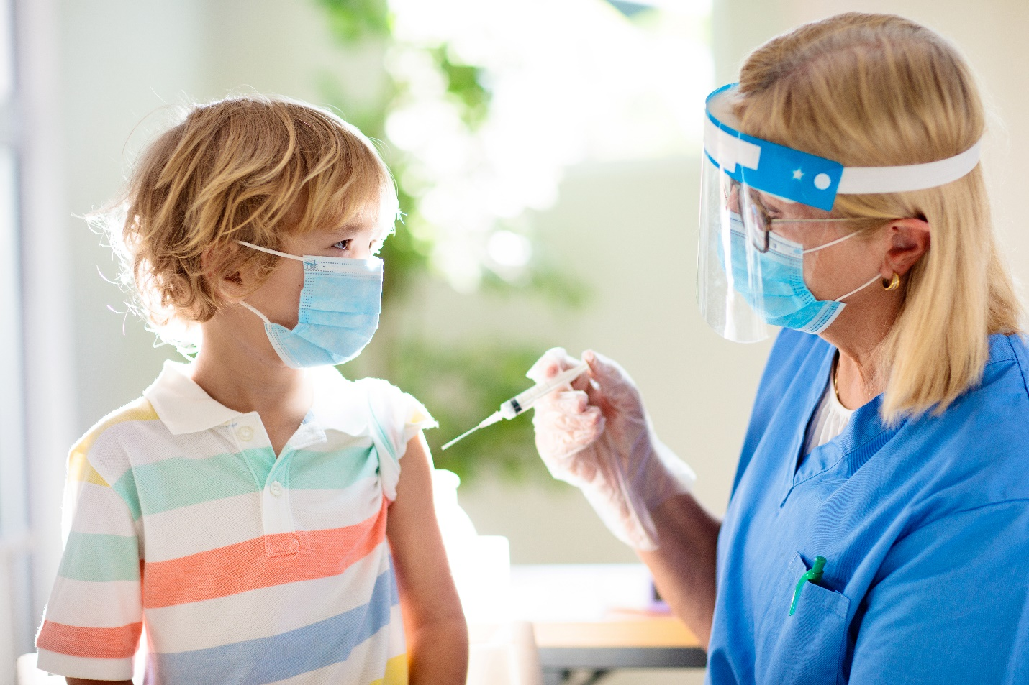

Then you will get a band aid.
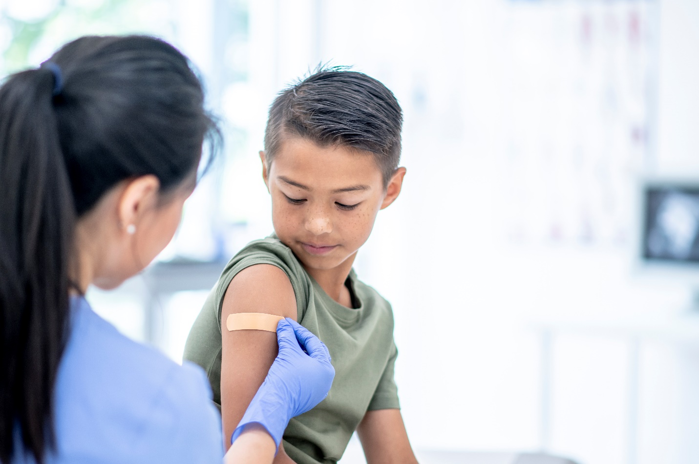

You will wait about 10 -15 minutes and can probably watch a video or read a book during this time too!

After that, you are all done! You will get a special card that says your name and that you got your vaccine.
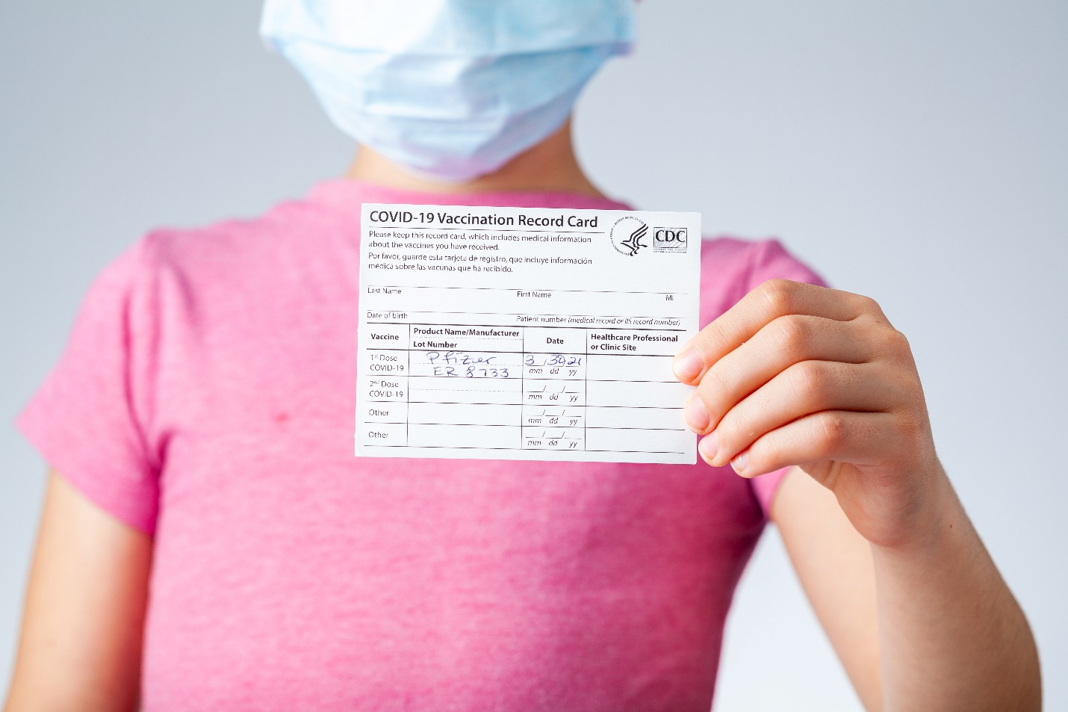
The vaccine keeps you healthy and it also helps keep everyone around you healthy! When you get the vaccine, you should be very proud of yourself for doing something that helps you and others. When you get a vaccine, you are one of the COVID fighting superheroes keeping everyone safe!
Great Job Superhero!
